Basic Electrical and Electronics Engineering Lab
(BEE01T1003)

Lab Manual



School of Electrical, Electronics and Communication Engineering

In-Charge | Name
Dean | Prof. B. Mahopatra
Programme Chair | Dr. Yogesh Kumar/Dr. Lokesh Varshney

University Vision

“To be known for world-class education, cutting-edge research, innovation, and application of knowledge to benefit society.”

University Mission

M1: To provide high-quality education, knowledge and skills necessary for our students to be successful in the technologically evolving world.
M2: To provide a supportive learning environment that facilitates discovery of new knowledge and continuous innovation
M3: To instil a culture of interdisciplinary enquiry and education that facilitates generation of cutting-edge solutions to real-world problems.
M4: To foster an environment that inculcates skills in life-long learning and team based problem solving.

Department Vision

“To be known globally as a premier department of Electronics and Communication Engineering for value-based education and interdisciplinary research for innovation.”

Department Mission

SM1: Create a strong foundation on fundamentals of Electronics and Communication Engineering through Outcome Based Learning Teaching (OBLT) Process.
SM2: Establish state-of -the-art facilities for design and simulation.
SM3: Provide opportunities to students to work on real world problems and develop sustainable ethical solutions.
SM4: Involve the students in group activities, including those of professional bodies to develop leadership and communication skills.

Programme Outcome (PO)

PO1: Engineering knowledge: Apply the knowledge of mathematics, science, engineering fundamentals, and an engineering specialization to the solution of complex engineering problems. PO2: Problem analysis: Identify, formulate, review research literature, and analyze complex engineering problems reaching substantiated conclusions using first principles of mathematics, natural sciences, and engineering sciences.
PO3: Design/development of solutions: Design solutions for complex engineering problems and design system components or processes that meet the specified needs with appropriate consideration for the public health and safety, and the cultural, societal, and environmental considerations.
PO4: Conduct investigations of complex problems: Use research-based knowledge and research methods including design of experiments, analysis and interpretation of data, and synthesis of the information to provide valid conclusions.
PO5: Modern tool usage: Create, select, and apply appropriate techniques, resources, and modern engineering and IT tools including prediction and modeling to complex engineering activities with an understanding of the limitations.
PO6: The engineer and society: Apply reasoning informed by the contextual knowledge to assess societal, health, safety, legal and cultural issues and the consequent responsibilities relevant to the professional engineering practice.
PO7: Environment and sustainability: Understand the impact of the professional engineering solutions in societal and environmental contexts, and demonstrate the knowledge of, and need for sustainable development.
PO8: Ethics: Apply ethical principles and commit to professional ethics and responsibilities and norms of the engineering practice.
PO9: Individual and team work: Function effectively as an individual, and as a member or leader in diverse teams, and in multidisciplinary settings.
PO10: Communication: Communicate effectively on complex engineering activities with the engineering community and with society at large, such as, being able to comprehend and write effective reports and design documentation, make effective presentations, and give and receive clear instructions.
PO11: Project management and finance: Demonstrate knowledge and understanding of the engineering and management principles and apply these to one’s own work, as a member and leader in a team, to manage projects and in multidisciplinary environments.
PO12: Life-long learning: Recognize the need for, and have the preparation and ability to engage in independent and life-long learning in the broadest context of technological change.

COURSE OBJECTIVES
- Verifying and analyzing the practical network circuits.
- Use of basic laboratory equipment and procedure to measure electrical quantities using laboratory test equipment such as multimeters, power supplies etc.
- Analyzing and solving different electrical and electronic circuits by applying different laws.
- Evaluate the performance of electrical and electronic circuits.
COURSE OUTCOMES
On completion of this course, the students will be able to
CO 1: Handle of basic electrical and electronics equipment’s.
CO 2: Measure electrical quantities and calculate various parameters.
CO 3: Understand and analyze the performance of various circuit connections.
CO 4: Design of basic electronic circuits and systems.
CO 5: Analyze the fundamental concepts involving electrical and electronics engineering.
CO6: Simulation of basic electronics circuits
CO-PO Mapping
Basic Electrical  and Electronics Engineering Lab  (BEE01T1003) |  | Engineering Knowledge | Problem analysis | Design/development of solutions | Conduct investigations of complex problems | Modern tool usage | The engineer and society | Environment and sustainability | Ethics | Individual or team work | Communication | Project management and finance | Life-long Learning | PSO 1 | PSO 2 | PSO 3
COs |  | 1 | 2 | 3 | 4 | 5 | 6 | 7 | 8 | 9 | 10 | 11 | 12 | 13 | 14 | 15
1 | Handle of basic electrical and electronics equipment’s. | 3 | 3 | 2 |  |  |  |  |  | 3 |  |  | 3 | 3
2 | Measure electrical quantities and calculate various parameters. | 3 | 3 | 3
3 | Understand and analyze the performance of various circuit connections. | 3 | 3 | 3 |  |  |  |  |  | 3 |  |  | 3 | 3
4 | Design of basic electronic circuits and systems | 3 | 3 | 2 | 3 |  |  |  |  | 3 |  |  | 2 | 3
5 | Analyze the fundamental concepts involving electrical and electronics engineering. | 3 | 3 | 3 | 1 |  |  |  |  | 3 |  |  | 1 | 3
6 | Simulation of basic electronics circuits | 2 | 2 | 2 |  |  |  |  |  |  |  |  | 1 | 1

Mode of Evaluation

Components | Laboratory
Components | Internal Examination | End Term Examination
Marks | 50 | 50
Total Marks | 100

Details Evaluation Scheme:
Component of evaluation | Evaluation | Rubric for CO | Marks
Experiment understanding | Internal | Design process | 10
Performance | Internal | Discussion of results | 20
Record | Internal | Quality of sketch, drawing and graphs | 10
Internal viva | Internal | Theory, tools, &team works | 10 (2+4+4)
Lab experiment | End term | Design process | 20
Lab Report | End term | Quality of sketch, drawing and graphs | 20
Viva by external expert | End term | Theory, tools, &team works | 10(2+4+4)
Total |  |  | 100

BEEE Lab Assessment Process-
- Faculty members must carry the attendance register.
- Before coming to class faculty members must have ensured the students get the lab manual.
- Clearly define the lab problem to the students and the expected outcome of the experiment.
- Clearly explain the objective and theory behind the lab experiments.
- All faculty members in a lab class shall actively participate in the lab experiment giving guidance to students.
- Faculty members must check the results obtained by each student and sign on it.
- Faculty members must correct the error in results and instruct student to do necessary modification in experiment to get the correct results.
- Faculty must take a note of any mal functioning of equipment or component if found during the tour of lab.
- Faculty must check and correct the student’s lab records.
- Faculty members evaluate the student’s performance in the lab class as a part of continuous evaluation.
- Faculty must give the assignment or lab problem to students for lab based solutions and shall assess the course outcomes based on performance of students.
- Faculty must ensure that each student endorse the following and upload in Moodle;
  - Preparation of data table and plot the graphs
  - students must explain data in table or graphs
  - Students must write the observation on data pattern or behavior of graphs.
  - Students must write the scientific justification of data variation or graphs behavior.
  - Students must write the error in results if any obtained during experiment.
- One course file is to be maintained for each course and all faculties must put the necessary documents of practice in the course file time to time.
- Faculty must declare the title of next experiment and must the students to go through lab manual before coming to lab.
- Faculty members must do the counseling to students who were absent in last class and instruct them to complete missed out experiment in extra time, otherwise the student will lose the marks.

LIST OF EXPERIMENTS
EXPERIMENT LIST
S. No. | Objective
1 | To familiarize with Electrical and Electronics Lab Equipment and basic Electronics Components
2 | To verify (i) Kirchhoff’s Current law (ii) Kirchhoff’s Voltage law.
3 | To verify the Norton’s Theorem.
4 | To verify the Thevenin’s Theorem.
5 | Observe the given waveform (Sinusoidal/Square/Triangular) and calculate its Frequency, Peak Value, Average Value, RMS Value and Form factor.
6 | To plot the V-I Characteristics of P-N Junction Diode and calculate the forward and reverse resistance of the Diode.
7 | To plot the V-I Characteristics and Verification of Regulation action of ZENER Diode.
8 | To verify the working of Half/Full Wave Rectifier Circuit and calculate its efficiency.
9 | To plot the input and output characteristics of a Bipolar Junction Transistor (BJT) in Common Emitter (CE) connection.
10 | Project – Students should be encouraged to make a working model/Project to demonstrate any Transducer/Sensor action or any related field
Exp (1): To familiarize with Measuring and testing equipments like Multimeter, CRO, Function Generator, Power Supply etc. and also familiarize with bread board, resistors and capacitors etc. Calculate the Resistance value according to Color band and verify the same by measuring through Multimeter.
Exp (2): To verify
- Kirchhoff’s Current law
- Kirchhoff’s Voltage law.
Exp (3): To verify the Norton’s Theorem.
Exp (4): To verify the Thevenin’s Theorem.
Exp (5): Observe the given waveform (Sinusoidal/Square/Triangular) and calculate it's Frequency, Peak Value, Average Value, RMS Value and Form factor.
Exp (6): To plot the V-I characteristics of P-N Junction Diode and calculate the forward and reverse resistance of the diode.
Exp (7): To plot the V-I characteristics and Verification of Regulation action of ZENER Diode.
Exp (8): To verify the working of Half/Full Wave Rectifier Circuit and calculate its efficiency.
Exp (9): To plot the input and output characteristics of Bipolar Junction Transistor (BJT) in Common Emitter connection.
Exp (10): PROJECT: Students should be encouraged to make a working model/Project to demonstrate any transducer/sensor action or any related field.

Mapping with Cos:
SN. | Experiments | Readings | Activities | COs
1 | To familiarize with Measuring and testing equipment’s like Multimeter, CRO, Function Generator, Power Supply etc and also familiarize with bread board, resistors and capacitors etc. | Text Books/Lab Manual | Bread board/Demo work | 1, 2, 3
2 | To verify:  (i) Kirchhoff’s current law  (ii) Kirchhoff’s voltage law | Text Books/Lab Manual | Bread board/ Demo work | 1, 2, 3, 4
3 | To verify the Norton’s Theorem. | Text Books/Lab Manual | Bread board/ Demo work | 1, 2, 3, 4
4 | To verify the Thevenin’s Theorem. | Text Books/Lab Manual | Bread board/ Demo work | 1, 2, 3
5 | Observe the given waveform (Sinusoidal/Square/Triangular) and calculate it's Frequency, Peak Value, Average Value, RMS Value and Form factor. | Text Books/Lab Manual | Bread board/ Demo work | 1, 2, 3, 5
6 | To plot the V-I characteristics of P-N Junction Diode and calculate the forward and reverse resistance of the diode. | Text Books/Lab Manual | Bread board/ Demo work | 1, 2, 3, 5
7 | Verification of Regulation action of ZENER Diode. | Text Books/Lab Manual | Bread board/ Demo work | 1, 2, 3, 5
8 | To verify the working of Half/Full Wave Rectifier Circuit and calculate its efficiency. | Text Books/Lab Manual | Bread board/ Demo work | 1, 2, 3, 5
9 | To plot the input and output characteristics of Bipolar Junction Transistor (BJT) in Common Emitter connection. | Text Books/Lab Manual | Bread board/ Demo work | 1, 2, 3, 5
10 | Students should be encouraged to make a working model/Project to demonstrate any transducer/sensor action or any related field | Text Books/Lab Manual | Bread board/ Demo work | 1, 2, 3, 5
Details of the Experiments
EXPERIMENT 1
OBJECTIVE: To familiarize with Measuring and testing equipments like Multimeter, CRO, Function Generator, Power Supply etc and also familiarize with bread board, resistors and capacitors etc. Calculate the Resistance value according to Color band and verify the same by measuring through Multimeter.

THEORY:
Cathode Ray Oscilloscope
Multimeter

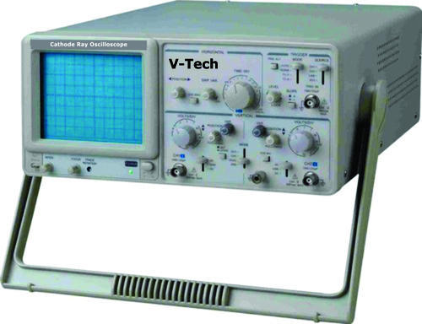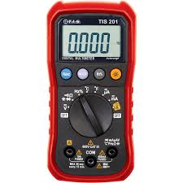

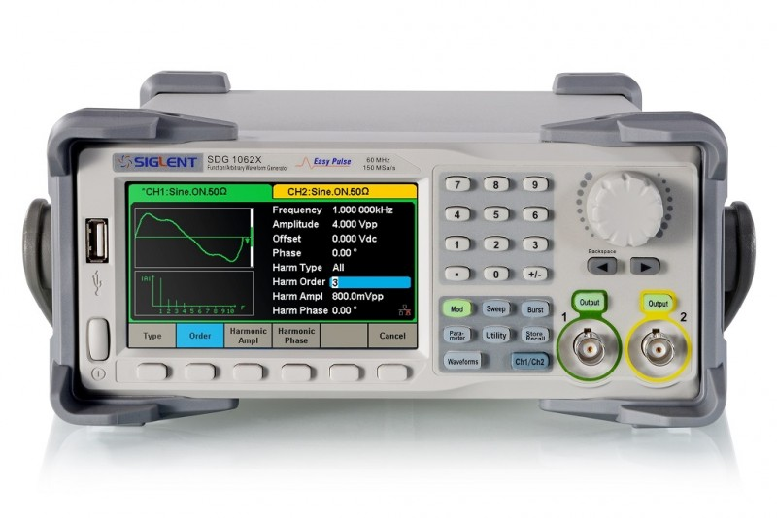

DSO

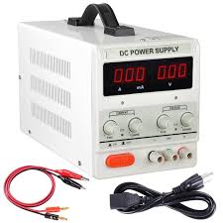
POWER SUPPLY

Bread Board

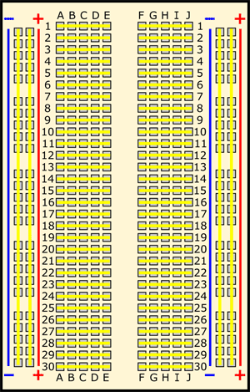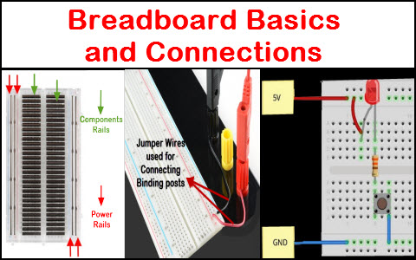

Testing of Resistance Value:
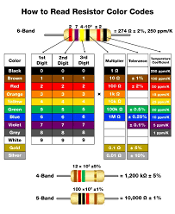

OBSERVATION TABLE:
S. No. | Resistor | Color Band | Calculated Value of “R” (Ohm) | Measured Value of “R” (Ohm) | Remark
1. | R1 | 1.  2.  3.  4. | 1
2. | R2 | 1.  2.  3.  4. | 3
3. | R3 | 1.  2.  3.  4. | 4
4. | R4 | 1.  2.  3.  4.

CALCULATIONS:

QUESTIONS:
- What do you understand by tolerance value in case of resistors?

EXPERIMENT 2 (A)
AIM: To verify the Kirchhoff’s current law (KCL).
OBJECTIVE: The objective of this Lab activity is to verify Kirchhoff's Current Law (KCL) using mesh and nodal analysis of the given circuit.
THEORY: According to Kirchhoff’s current law, in any network of wires carrying currents, the algebraic sum of all currents meeting at a junction (or node) is zero or the sum of incoming currents towards any junction (or node) is equal to the sum of outgoing currents away from that junction.
APPARATUS REQUIRED:
S. No. | Equipment | Specification | Quantity | Remark
1. | Regulated power DC Supply | 0-24V | 1
2. | PMMC Ammeter | 0-1A | 3
3. | Resistances/Rheostats |  | 4
4. | Connecting Wires

CIRCUIT DIAGRAM:
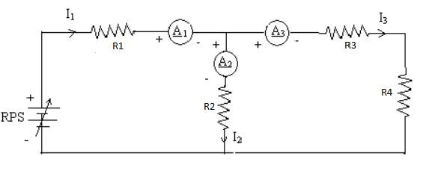
Figure 1 Circuit Diagram
PROCEDURE: Four Resistance R₁, R₂, R₃and R₄; and ammeters A₁, A₂and A₃are connected to DC battery or regulated DC power supply as shown in figure. The Four Resistances are connected as per circuit diagram, supply is switched on and the reading of the ammeter A₁, A₂and A₃are noted. The process may be repeated by varying either of resistancesR₁, R₂, R₃and R₄.
OBSERVATIONS:
S. No. | Reading of Ammeter A₁ (I₁) | Reading of Ammeter A₂ (I₂) | Reading of Ammeter A₃ (I₃) | I₂+I₃
1.
2.
3.
4.
5.

WORKING PRINCIPLE: The algebraic sum of currents in a network of conductors meeting at a point is zero. Recalling that current is a signed (positive or negative) quantity reflecting direction towards or away from a node; this principle can be stated as:
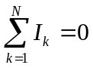
N is the total number of branches with currents flowing towards or away from the node.The law is based on the conservation of charge whereby the charge (measured in coulombs) is the product of the current (in amperes) and the time (in seconds).
KEY PARAMETERS: Letand also calculate the error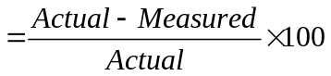.
EXPERIMETAL RESULTS:
- Calculate the ideal voltages and currents for each element in the circuit and compare them to the measured values.
- Compute the percentage error in the two measurements and provide a brief explanation for the error.
PRECAUTIONS:
- All connections should be tight.
- All steps should be followed carefully.
- Readings and calculation should be taken carefully.
- Don’t touch the live terminals.

QUESTIONS:
- What is KCL?
- What is ohm’s law?
- What is difference between emf and potential difference?
- Why ammeters are connected in series to measure current?
- If the length of a wire of resistance R is uniformly stretched to n times its original value, what will be its new resistance?

________________________________________________________________

EXPERIMENT 2(B)
AIM: To verify the Kirchhoff’s voltage law (KVL).
OBJECTIVE: The objective of this Lab activity is to verify Kirchhoff's voltage Law (KVL) using mesh and nodal analysis of the given circuit.
THEORY: According to Kirchhoff’s voltage law, in any closed circuit or mesh, the algebraic sum of emf acting in the circuit or mesh is equal to the algebraic sum of the products of the currents and resistances of each part of the circuit or mesh.
APPARATUS REQUIRED:
S. No. | Equipment | Specification | Quantity | Remark
1. | Regulated power DC  supply or Battery | 0-24V | 1
2. | PMMC Voltmeter | 0-24V | 4
3. | Resistances/Rheostats |  | 4
4. | Connecting Wires

CIRCUIT DIAGRAM:
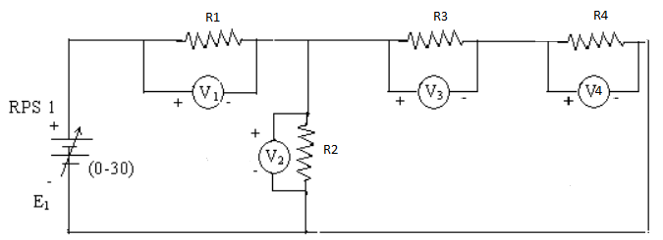
Figure 2 KVL Circuit Diagram

PROCEDURE: Resistances R₁, R₂, R₃ and R₄; and three voltmeters V₁, V₂ , V₃ and V₄are connected to DC battery or regulated power supply as shown in figure. Three rheostats are set their maximum values, supply is switched on and the reading of the voltmeters V₁, V₂, V₃and V₄ is noted. The process may be repeated by varying either of resistances R₁, R₂, R₃ and R₄.
OBSERVATIONS:
S. No. | Reading  of Voltmeter V₁(Volts) | Reading  of Voltmeter V₂(Volts) | Reading  of Voltmeter V₃(Volts) | Reading  of Voltmeter V₄(Volts) | V=V₁+V₂ | V₂=V₃+V₄
WORKING PRINCIPLE: The sum of the emfs in any closed loop is equivalent to the sum of the potential drops in that loop, or: The algebraic sum of the products of the resistances of the conductors and the currents in them in a closed loop is equal to the total emf available in that loop.Similar to KCL, it can be stated as:
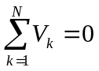
N is the total number of branches with currents flowing towards or away from the node.This law is based on the conservation of energy whereby voltage is defined as the energy per unit charge. The total amount of energy gained per unit charge must be equal to the amount of energy lost per unit charge, as energy and charge are both conserved.
KEY PARAMETERS: Let and also calculate the error.
EXPERIMENT RESULT:
- Calculate the ideal voltages and currents for each element in the circuit and compare them to the measured values.
- Compute the percentage error in the two measurements and provide a brief explanation for the error.

PRECAUTIONS:
- All connections should be tight.
- All steps should be followed carefully.
- Readings and calculation should be taken carefully.
- Don’t touch the live terminals.

QUESTIONS:
- What is KVL?
- What is ohm’s law?
- Why voltmeters are connected in parallel to rheostats to measure voltage?
- How does the resistance of a homogeneous material having constant length vary with the changing cross-sectional area?
- What is Fleming’s left hand rule?
- What is Fleming’s right hand rule?
- Define junction and node.
- Define Mesh and loop.

EXPERIMENT 3
AIM: To verify the Norton’s Theorem.
APPARATUS REQUIRED:
S. No. | Equipment | Specification | Quantity | Remark
1. | Two regulated DC power  supply | 0-12V and 0-5A | 1
2. | PMMC Voltmeter | 0-10V | 1
3. | PMMC Ammeter | 0-5A | 1
4. | Resistances/Rheostats |  | 4/1
5. | Connecting Wires

BRIEF THEORY: According to this theorem if a resistor of RL ohms be connected between any two terminals of a linear bilateral network, then the resulting current through load resistor will be equal to 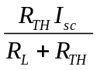 where 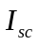is the short circuit current through load terminal points and 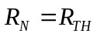 is the resistance of network measured between these two points. is the short circuit current through load terminal points, RN is the equivalent resistance across the terminals , RL is the load resistance .
CIRCUIT DIAGRAM:
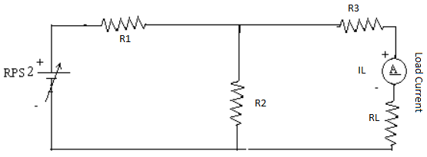
To find V_{N} =V_{TH}
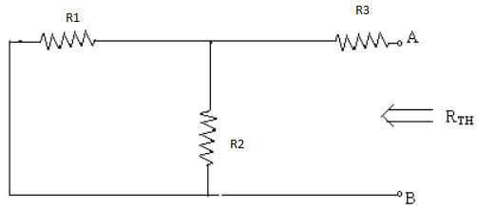
To find I_{sc}
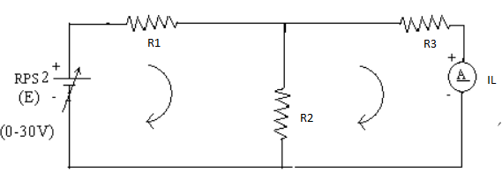
Norton’s Equivalent Circuit
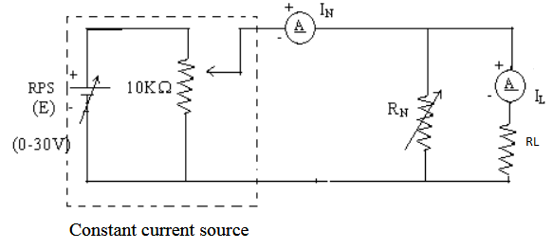

PROCEDURE:
- Remove the resistance (called Load Resistance RL).
- Find the short circuit current which flow through the short circuited two load terminals from where resistance is removed. It is also called short circuit current.
- Compute the resistance of the whole network as looked into from these two terminals after all sources of e.m.f. are treated as short circuited while all the current sources are treated as open circuited.
- Connect RL back to its terminals from where previously it was removed and measure the current flowing through RL.
- Finally, calculate the current flowing through RL using the equation 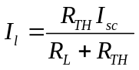
OBSERVATIONS:
S. No. | Short circuit current through load terminals | Equivalent resistance across the load R_{L} terminals, R_{Th} | Load Current | Measured I_{l}
CALCULATION: The load current
RESULT AND DISCUSSION:
The value of short circuit crrent is .....Amp.
The value of Norton’s resistance is .....ohms.
It will be found that measured value of current flowing through the load IL is the same as determined by Norton’s theorem.
OUTCOMES: Students are able to analyze Norton’s theorem in resistive circuit.

PRECAUTIONS:
  - All connections should be tight.
  - All steps should be followed carefully.
  - Readings and calculation should be taken carefully.
  - Don’t touch the live terminals.
PRE-EXPERIMENT QUESTIONS:
  - What do you mean by bilateral and unilateral circuits?
  - What is current source?
POST EXPERIMENT QUESTIONS:
  - State of Norton’s theorem.
  - What is the utility of Norton’s theorem?

EXPERIMENT 4
AIM: To verify the Thevenin’s Theorem.
APPARATUS REQUIRED:
S. No. | Equipment | Specification | Quantity | Remark
1. | Two regulated DC power  supply | 0-12V and 0-6V | 1
2. | PMMC Voltmeter | 0-10V | 1
3. | PMMC Ammeter | 0-5A | 1
4. | Resistances/Rheostats |  | 4/1
5. | Connecting Wires
BRIEF THEORY: According to this theorem if a resistor of R_{L} ohms be connected between any two terminals of a linear bilateral network, then the resulting current through load resistor will be equal to 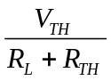 where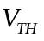 is the potential difference across these two points and 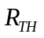 is the resistance of network measured between these two points. is the open circuit voltage across the terminals, R_{Th} is the equivalent resistance across the terminals , R_{L} is the load resistance .
CIRCUIT DIAGRAM:
To find V_{TH}
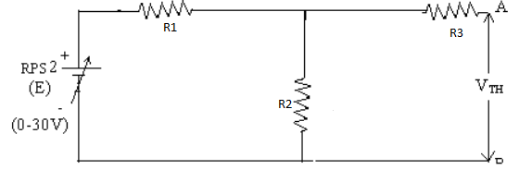
To find R_{TH}
Thevenin’s Equivalent Circuits
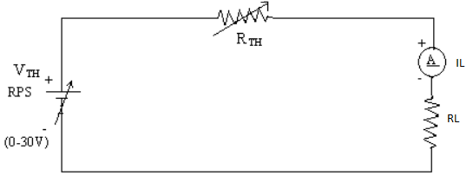
PROCEDURE:
- Remove the resistance (called Load Resistance R_{L}).
- Find the open circuit voltage V_{OC} which appears across the two terminals from where resistance is removed. It is also called Thevenin’s voltage .
- Compute the resistance of the whole network as looked into from these two terminals after all sources of e.m.f. are treated as short circuited while all the current sources are treated as open circuited.
- Connect R_{L} back to its terminals from where previously it was removed and measure the current flowing through R_{L}.
- Finally, calculate the current flowing through R_{L} using the equation
OBSERVATIONS:
S. No. | Open circuit voltage across load R_{L} terminals (VOC) | Equivalent resistance across the load R_{L} terminals, R_{Th} | Load Current  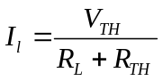 | Measured I_{l}

CALCULATION: The load current
RESULT AND DISCUSSION:
The value of open circuit voltage (V_{OC}) is .....volts.
The value of Thevenin’s resistance is .....ohms.
The value of current acrossload is ......amps.
It will be found that measured value of current flowing through the load I_{L} is the same as determined by Thevenin’s theorem.
OUTCOMES: Students are able to analyze Thevenin’s theorem in presence of DC source.
PRECAUTIONS:
  - All connections should be tight.
  - All steps should be followed carefully.
  - Readings and calculation should be taken carefully.
  - Don’t touch the live terminals.
PRE-EXPERIMENT QUESTIONS:
- What do you mean by bilateral and unilateral circuits?
- What is voltage source?
POST EXPERIMENT QUESTIONS:
  - State of Thevenin’s theorem.
  - What is the utility of Thevenin’s theorem?

EXPERIMENT 5
AIM: Observe the given waveform (Sinusoidal/Square/Triangular) and calculate it's Frequency, Peak Value, Average Value, RMS Value and Form factor.

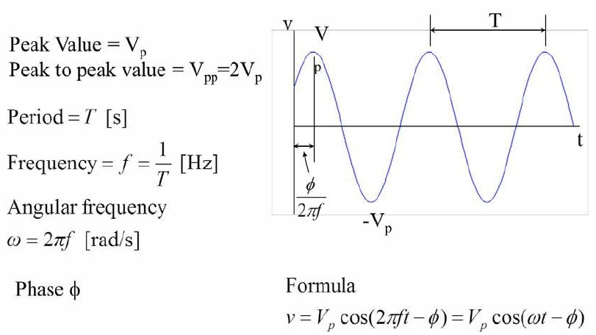
THEORY:

APPARATUS REQUIRED:

S. No. | Equipment | Specification | Quantity | Remark
1. | Function Generator
2. | CRO

PROCEDURE:
- Connect the CRO probes to output of function Generator.
- Switch on the Function generator and CRO.
- Observe the Sine waveform and measure its peak voltage, time period
Calculate the Frequency, Peak Value, Average Value, RMS Value and Form factor of the Sine wave using the formula.
- Repeat the experiment for different type of waveform (Triangular wave, Square wave) and measure the listed parameters.

OBSERVATIONS:

S. No. | Sine Wave | Triangular Wave | Square Wave
Peak Voltage
Time Period

CALCULATIONS: Calculate the listed electrical parameters using formula.

PRECAUTIONS:
- All connections should be tight.
- All steps should be followed carefully.
- Readings and calculation should be taken carefully.

QUESTIONS:
- What is the formula for RMS value?
- How is average value different from RMS value?
- What is Form factor?
EXPERIMENT 6
AIM: To verify the functionality of PN junction diode in forward bias and reverse bias.
OBJECTIVE: To study Volt-Ampere Characteristics of P-N Diode and also find cut-in voltage for P-N Junction diode.
THEORY: Operation: A PN junction diode is formed when a single crystal of semiconductor is doped with acceptors impurities (Pentavalent) on one side and donor impurities (Trivalent) on the other side. It has two terminals called electrodes, one each from P-region and N-region. Due to two electrodes it is called (i.e., Di-electrode) Diode.
Biasing of PN junction Diode:
Applying external D.C. voltage to any electronic device is called biasing. There is no current in the unbiased PN junction at equilibrium. Depending upon the polarity of the D.C. voltage externally applied to diode, the biasing is classified as forward biasing and Reverse biasing.
Forward bias operation: The P-N junction supports uni-directional current flow. If +ve terminal of the input supply is connected to anode (P-side) and –ve terminal of the input supply is connected the cathode. Then diode is said to be forward biased. In this condition the height of the potential barrier at the junction is lowered by an amount equal to given forward biasing voltage. Both the holes from p-side and electrons from n-side cross the junction simultaneously and constitute a forward current from n-side cross the junction simultaneously and constitute a forward current (injected minority current – due to holes crossing the junction and entering P- side of the diode). Assuming current flowing through the diode to be very large, the diode can be approximated as short- circuited switch.
Reverse bias operation: If negative terminal of the input supply is connected to anode (p-side) and –ve terminal of the input supply is connected to cathode (n-side) then the diode is said to be reverse biased. In this condition an amount equal to reverse biasing voltage increases the height of the potential barrier at the junction. Both the holes on P-side and electrons on N-side tend to move away from the junction there by increasing the depleted region. However the process cannot continue indefinitely, thus a small current called reverse saturation current continues to flow in the diode. This current is negligible; the diode can be approximated as an open circuited switch.
Diode current equation: The volt-ampere characteristics of a diode explained by the following equations:
I = current flowing in the diode, I₀ = reverse saturation current
V = Voltage applied to the diode
V_{T} = volt- equivalent of temperature = k T/q = T/ 11,600 = 26mV (@ room temp)
=1 (for Ge) and 2 (for Si). It is observed that Ge diodes has smaller cut-in-voltage when compared to Si diode. The reverse saturation current in Ge diode is larger in magnitude when compared to silicon diode.
APPARATUS REQUIRED:
S. No. | Components/Equipments | Quantity | Remarks
1 | Diode (1N4007) | 1
2 | Resistor (1K) | 1
3 | Dual DC Regulated Power supply (0 - 30 V) | 1
4 | Digital Ammeters ( 0 - 200 mA, 0 - 200 µA) | 1
5 | Digital Voltmeter (0 - 20V) | 1
6 | Connecting wires | 1
7 | Bread board | 1

CIRCUIT DIAGRAM:
Forward Bias Condition: Forward Bias Condition is given as
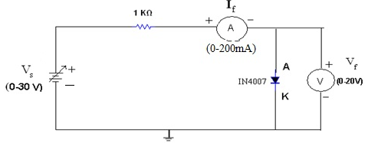
Figure: Forward Bias Connection

Reversed Bias Condition: Reversed Bias Condition is given as:
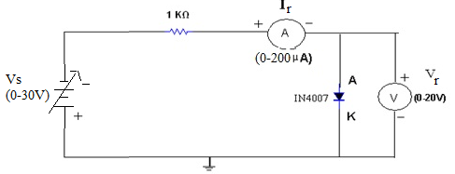
Figure: Reverse Biased Connection
PROCEDURE: Forward Bias Condition:
- Connect the circuit as shown in figure (1) using PN Junction diode.
- Initially vary Regulated Power Supply (RPS) voltage V_{s} in steps of 0.1 V. Once the current starts increasing vary V_{s} from 1V to 12V in steps of 1V and note down the corresponding readings V_{f} and I_{f}.
- Tabulate different forward currents obtained for different forward voltages.
Reverse Bias Condition:
- Connect the circuit as shown in figure (2) using PN Junction diode.
- Vary V_{s} in the Regulated Power Supply (RPS) gradually in steps of 1V from 0V to 12V and note down the corresponding readings V_{r} and I_{r}.
- Tabulate different reverse currents obtained for different reverse voltages.
- To get the graph in reverse region (theoretically), remove voltmeter and with reference to the supply voltage note down the reverse current readings in Ammeter because current always selects low reactance path.(Diode have infinite resistance in reverse bias ideally).To get the graph in reverse region (theoretically), replace voltmeter with nano ammeter. Voltmeter has less load resistance when compared to diode. Current conducts in low resistance path.
OBSERVATIONS: Forward Bias Condition:
RPS Voltage V_{s} (volts) | Forward Voltage across the diode V_{f} (volts) | Forward Current through the diode I_{f} (mA)
1
2
3
4
5
6
7
8
9
10
Reverse Bias Condition:
RPS Voltage V_{s} (volts) | Reverse Voltage across the diode V_{r} (volts) | Reverse Current through the diode I_{r} (µA)
1
2
3
4
5
6
7
8
9
10
Graph:
- Take a graph sheet and divide it into 4 equal parts. Mark origin at the center of the graph sheet.
- Now mark +ve X-axis as V_{f}, -ve X-axis as V_{r}, +ve Y-axis as I_{f} and –ve Y-axis as I_{r}.
- Mark the readings tabulated for Si forward biased condition in first Quadrant and Si reverse biased condition in third Quadrant.
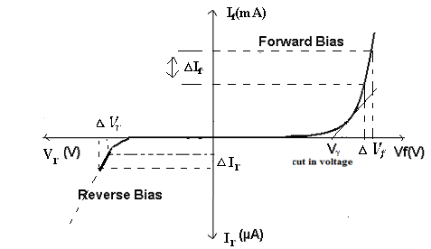
Fig: V- I Characteristics of PN Junction Diode under Forward & Reverse Bias Conditions

KEY PARAMETERS:
List of Parameters | SILION DIODE (1N4007)
Maximum Forward Current | 1A
Maximum Reverse Current | 5.0µA
Maximum Forward Voltage | 0.8V
Maximum Reverse Voltage | 1000V
Maximum Power Dissipation | 30mW
Temperature | -65 to 200° C
EXPERIMENT RESULT:
- Calculate the ideal voltages and currents for each element in the circuit and compare them to the measured values.
- Compute the percentage error in the two measurements and provide a brief explanation for the error.
- Give the explanation regarding the error in terms of different causes etc.
- Explain the behavior of the graph and why it is so?
PRECAUTIONS:
- While doing the experiment do not exceed the readings of the diode. This may lead to damaging of the diode.
- Connect voltmeter and ammeter in correct polarities as shown in the circuit diagram.
- Do not switch ON the power supply unless you have checked the circuit connections as per the circuit diagram.
QUESTIONS:
- What are trivalent and pentavalent impurities?
- How PN junction diode does acts as a switch?
- What is diode current equation?
- What is the value of V_{t} at room temperature?
- Dynamic resistance expression?
- What is a semiconductor?
- What is meant by intrinsic semiconductor?
- What is the order of energy gap in a pure semiconductor?
- What is an extrinsic semiconductor?
- What is a doped semiconductor?
- What is doping?
- What are two different types of impurities?
- To which group does a (i) p-type, (ii) n type impurity belong?
- What are the charge carriers in a pure semiconductor?
- What are the charge carriers in n-type semiconductor?
EXPERIMENT 7
AIM: To Plot the V-I Characteristics and verify the functionality the regulation action of Zener diode.
OBJECTIVE: To plot the Volt-Ampere Characteristics of Zener Diode and also find Zener Breakdown Voltage in Reverse Biased conditions and observe the regulation action.
THEORY:
Zener diodes are a special kind of diode which permits current to flow in the forward direction. What makes them different from other diodes is that Zener diodes will also allow current to flow in the reverse direction when the voltage is above a certain value. This breakdown voltage is known as the Zener voltage. In a standard diode, the Zener voltage is high, and the diode is permanently damaged if a reverse current above that value is allowed to pass through it. Zener diodes are designed in a way where the Zener voltage is a much lower value. There is a controlled breakdown which does not damage the diode when a reverse current above the Zener voltage passes through a Zener diode.
The most common values for nominal working voltage are 5.1 V, 5.6 V, 6.2 V, 12 V and 15 V. We also carry Zener diodes with nominal working voltage up to 1 kV. Forward (drive) current can have a range from 200 uA to 200 A, with the most common forward (drive) current being 10 mA or 200 mA. In the forward bias direction, the zener diode behaves like an ordinary silicon diode.
In the reverse bias direction, there is practically no reverse current flow until the breakdown voltage is reached. When this occurs there is a sharp increase in reverse current. Varying amount of reverse current can pass through the diode without damaging it. The breakdown voltage or zener voltage (V_{Z}) across the diode remains relatively constant. The maximum reverse current is limited, however, by the wattage rating of the diode.
Avalanche Break down:
When the diode is in the reverse bias condition, the width of the depletion region is more. If both p-side and n-side of the diode are lightly doped, depletion region at the junction widens. In reverse bias, the minority charge carrier current flows through junction. As the applied reverse voltage increases the minority carriers acquire sufficient energy to collide with the carriers in the covalent bonds inside the depletion region. As a result, the bond breaks and electron hole pairs are generated. The process becomes cumulative and leads to the generation of a large number of charge carriers resulting in Avalanche Breakdown.
Zener Break down:
If both p-side and n-side of the diode are heavily doped, depletion region at the junction reduces compared to the width in normal doping. Applying a reverse bias causes a strong electric field get applied across the device. As the reverse bias is increased, the Electric field becomes strong enough to rupture covalent bonds and generate large number of charge carriers. Such sudden increase in the number of charge carriers due to rupture of covalent bonds under the influence of strong electric field is termed as Zener breakdown.
Zener Diode as Voltage Regulator:
The function of a regulator is to provide a constant output voltage to a load connected in parallel with it in spite of the ripples in the supply voltage or the variation in the load current and the zener diode will continue to regulate the voltage until the diodes current falls below the minimum I_{Z}(min) value in the reverse breakdown region. It permits current to flow in the forward direction as normal, but will also allow it to flow in the reverse direction when the voltage is above a certain value - the breakdown voltage known as the Zener voltage. The Zener diode specially made to have a reverse voltage breakdown at a specific voltage. Its characteristics are otherwise very similar to common diodes. In breakdown the voltage across the Zener diode is close to constant over a wide range of currents thus making it useful as a shunt voltage regulator.
The purpose of a voltage regulator is to maintain a constant voltage across a load regardless of variations in the applied input voltage and variations in the load current. The resistor is selected so that when the input voltage is at V_{IN}(min) and the load current is at I_{L}(max) that the current through the Zener diode is at least I_{z}(min). Then for all other combinations of input voltage and load current the Zener diode conducts the excess current thus maintaining a constant voltage across the load. The Zener conducts the least current when the load current is the highest and it conducts the most current when the load current is the lowest.
APPARATUS REQUIRED:
S. No. | Components/Equipments | Quantity | Remarks
1 | Zener Diodes (1N4735A) | 1
2 | Resistors (1K, 3.3) | 1
3 | Dual DC Regulated Power supply (0 - 30 V) | 1
4 | Digital Ammeters ( 0 - 200 mA, 0 - 200 µA) | 1
5 | Digital Voltmeter (0 - 20V) | 1
6 | Connecting wires | 1
7 | Bread board | 1

CIRCUIT DIAGRAM:
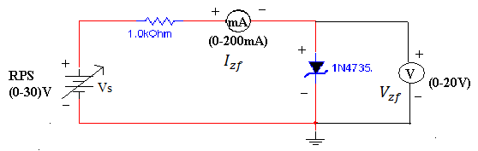 Figure: Forward Bias Condition

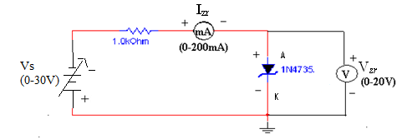
Figure: Reverse Bias Condition
PROCEDURE: a) Forward Bias Condition:
- Connect the circuit as shown in figure (1).
- Initially vary V_{s} in steps of 0.1V. Once the current starts increasing vary V_{s} in steps of 1V up to 12V. Note down the corresponding readings of V_{zf} and I_{zf}.
b) Reverse Bias Condition:
- Connect the circuit as shown in figure (2).
- Vary V_{s} gradually in steps of 1V up to 12V and note down the corresponding readings of V_{zr} and I_{zr}.
- Tabulate different reverse currents obtained for different reverse voltages.

OBSERVATIONS:
Table: 1 Forward Bias Condition:
RPS Voltage Vs(volts) | Forward Voltage across the diode V_{zf} (volts) | Forward Current through the diode I_{zf} (mA)
Table: 2 Reverse Bias Condition:
RPS Voltage Vs(volts) | Reverse Voltage across the diode V_{zr} (volts) | Reverse Current through the diode I_{zr} (mA)
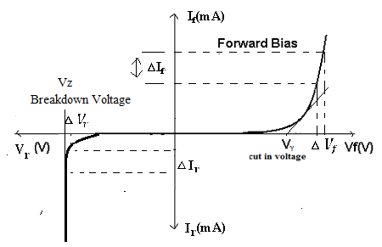
Fig: V- I Characteristics of Zener Diode under Forward & Reverse Bias Conditions

KEY PARAMETERS:
- Breakdown Voltage = 5.1V
- Power dissipation = 0.75W
- Max Forward Current = 1A
EXPERIMENT RESULT:
- Calculate the ideal voltages and currents for each element in the circuit and compare them to the measured values.
- Compute the percentage error in the two measurements and provide a brief explanation for the error.
- Give the explanation regarding the error in terms of different causes etc.
- Explain the behavior of the graph and why it is so?
PRECAUTIONS:
- While doing the experiment do not exceed the readings of the diode. This may lead to damaging of the diode.
- Connect voltmeter and ammeter in correct polarities as shown in the circuit diagram.
- Do not switch ON the power supply unless you have checked the circuit connections as per the circuit diagram.
QUESTIONS:
- What is the doping concentration in Zener diodes?
- Can we use Zener diode as a switch?
- What is PIV of Zener?
- What will happen if P-N regions are heavily doped in Zener diode?
- List the other Zener diodes with different breakdown voltages.
- Is the breakdown region in Zener really destructible?
- What is a Zener diode?
- How the name of the Zener came?
- What is cause of reverse breakdown?
- What is Zener voltage?
- What are trivalent and penatavalent impurities?
- What is the difference between p-n Junction diode and zener diode?
- What is break down voltage?
- What are the applications of Zener diode?
- What is cut-in-voltage?

EXPERIMENT 8
AIM: To study working of the Half/Full wave bridge rectifier and calculate its efficiency.
OBJECTIVE: To verify the working of Full Wave Rectifiers Circuit (Bridge Rectifier) and calculate it’s efficiency.

APPARATUS REQUIRED:

S. No. | Components/Equipments | Quantity | Remarks
1 | CRO | 1
2 | Multimeter | 1
3 | Trainer Kit | 1
4 | Bread Board | 1
5 | Connecting wires
6 | Diode | 4
7 | Power Supply | 1

Theory: -
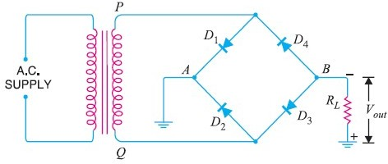
Full Wave Bridge Rectifier – Circuit Diagram

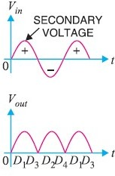
Input and Output Waveform of Full-wave Bridge Rectifier.

WORKING:

The full wave bridge rectifier circuit contains four diodes D1 , D2,D3 and D4, connected to form a bridge as shown in Fig(4).
The a.c. supply to be rectified is applied to the diagonally opposite ends of the bridge through the transformer. Between other two ends of the bridge, the load resistance RL is connected.

Operation:

During the positive half-cycle of secondary voltage, the end P of the secondary winding becomes positive and end Q negative.
This makes diodes D1 and D3 forward biased while D2 and D4 are reverse biased. Hence only diodes D1 and D3 conducts.
These two diodes will be in series through the load RL as shown in Figure.
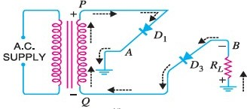
The conventional current flows through load RL is shown by the dotted arrows. It may be seen that current flows from A to B through the load RL.
During the negative half cycle of secondary voltage, end P becomes negative and end Q positive.
This makes diodes D2 and D4and forward biased and diodes D1 and D3 are reverse biased. Hence only diodes D2 and D4 conduct.
These two diodes will be in series through the load RL as shown in Figure.
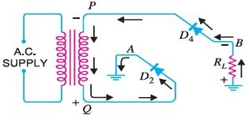
The conventional current flow through load RL is shown by the solid arrows.

It may be seen that again the current flows from A to B through the load i.e. in the same direction as for the positive half-cycle. Therefore, d.c. output is obtained across load RL.
Peak Inverse Voltage
The peak inverse voltage (PIV) of each diode is equal to the maximum secondary voltage of transformer i.e. Vm.
Suppose during positive half cycle of input a.c., end P of secondary is positive and end Q negative. Under such conditions, diodes D1 and D3 are forward biased while diodes D2 and D4 are reverse biased. Since the diodes are considered ideal, diodes D1 and D3 can be replaced by wires as shown in Fig. 7 (i). This circuit is the same as shown in Figure.
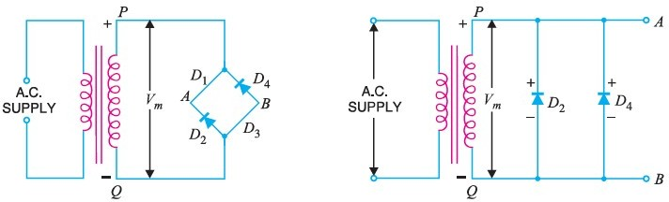

From the Figure, it is clear that two reverse biased diodes (i.e., D2 and D4) and the secondary of transformer are in parallel. Hence PIV of each diode (D2 and D4) is equal to the maximum voltage (Vm) across the secondary.Similarly, during the next half cycle, D2 and D4 are forward biased while D1 and D3 will be reverse biased. It is easy to see that reverse voltage across D1 and D3 is equal to Vm.
Hence, PIV = Vm

Procedure:

- Connect the primary of center-tapped transformer to main supply. At the output points of full wave rectifier circuit, connect the vertical plates of CRO & by adjusting its knob, get a stationary pattern on the screen. Now touch the CRO probes at the center tap & one of the diodes. Observe the waves shapes on CRO compare the two wave shapes.
- By Multimeter, measure the AC voltage at the input & output points. Also measure the dc voltage at the output point.
- Multiply the ac input voltage by √2 to get peak value & calculate the dc voltage by Vdc = Vm / π, Compare this theoretical value with the practical value.
- Calculate the ripple Factor by using formula.

- Measure the PIV across the diode. It should be 2Vm.

Observation:- Observe the wave shape of output signal of FWR on the CRO.

Observation Table:-

SR. NO. | Applied Input Voltage | Observe Output Voltage | Remark

Calculation:-
Ripple Factor of FWR = ac voltage at o/p / dc voltage at o/p =

Results:

  - The output dc voltage is little less than the theoretical value.
  - There is little difference between theoretical & measured value of ripple Factor.

EXPERIMENT 9

AIM: To study the input and output characteristics of a NPN transistor in Common Emitter (CE) configuration.
OBJECTIVE: To obtain input resistance find V_{BE} and I_{B} for a constant V_{CE} on one of the input characteristics and output resistance find I_{C} and V_{CB} at a constant I_{B}.
THEORY: The basic circuit diagram for studying input characteristics is shown in the circuit diagram. The input is applied between base and emitter, the output is taken between collector and emitter. Here emitter of the transistor is common to both input and output and hence the name Common Emitter Configuration.
Input characteristics are obtained between the input current and input voltage at constant output voltage. It is plotted between V_{BE} and I_{B} at constant V_{CE} in CE configuration.
Output characteristics are obtained between the output voltage and output current at constant input current. It is plotted between V_{CE} and I_{C} at constant I_{B} in CE configuration.
APPARATUS REQUIRED:
S. No. | Components/Equipments | Quantity | Remarks
1 | Transistor BC 107 | 1
2 | Resistors (1K, 100K) | 1
3 | Dual DC Regulated Power supply (0 - 30 V) | 1
4 | Digital Ammeters ( 0 - 200 mA, 0 - 200 µA) | 1
5 | Digital Voltmeter (0 - 20V) | 1
6 | Connecting wires | 1
7 | Bread board | 1

CIRCUIT DIAGRAM:
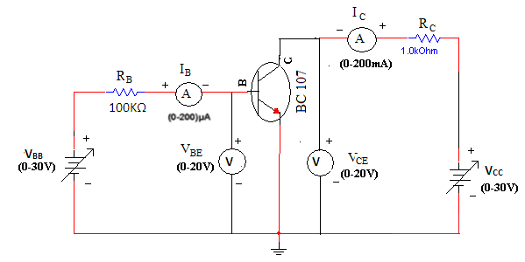
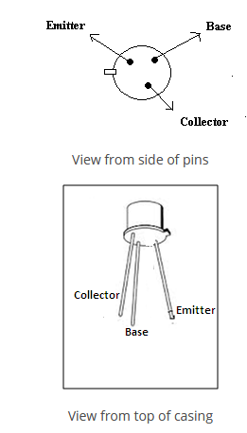

PROCEDURE:
Input Characteristics:
- Connect the circuit as shown in the circuit diagram.
- Keep output voltage V_{CE} = 0V by varying V_{CC}.
- Varying V_{BB} gradually, note down base current I_{B} and base-emitter voltage V_{BE}.
- Step size is not fixed because of non linear curve. Initially vary V_{BB} in steps of 0.1V. Once the current starts increasing vary V_{BB} in steps of 1V up to 12V.
- Repeat above procedure (step 3) for V_{CE} = 5V.
Output Characteristics:
- Connect the circuit as shown in the circuit diagram.
- Keep emitter current I_{B} = 20A by varying V_{BB}.
- Varying V_{CC} gradually in steps of 1V up to 12V and note down collector current I_{C} and Collector-Emitter Voltage (V_{CE}).
- Repeat above procedure (step 3) for I_{B} = 60µA, 0µA.

OBSERVATIONS:
Input Characteristics
V_{BB} (Volts) | V_{CE} = 0V |  |  |  | V_{CE} = 5V
V_{BB} (Volts) | V_{BE} (Volts) |  | I_{B} (µA) |  | V_{BE} (Volts) | I_{B} (µA)
Output Characteristics
V_{CC} (Volts) | I_{B} = 0 µA |  |  | I_{B} = 20 µA |  | I_{B} = 40 µA
V_{CC} (Volts) | V_{CE} (Volts) | I_{C} (mA) |  | V_{CE} (Volts) | I_{C} (mA) | V_{CE} (Volts) | I_{C} (mA)

GRAPH:
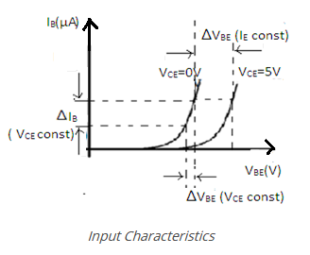
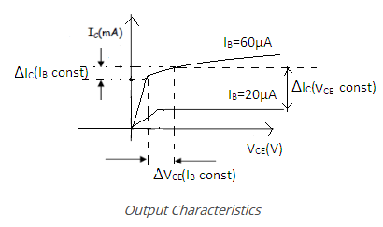
- Plot the input characteristics by taking V_{BE} on X-axis and I_{B} on Y-axis at a constant V_{CE} as a constant parameter.
- Plot the output characteristics by taking V_{CE} on X-axis and taking I_{C} on Y-axis taking I_{B} as a constant parameter.
KEY PARAMETERS:
- Max Collector Current = 0.1A
- V_{CEO} max = 50V

EXPERIMENT RESULT:
- Calculate the ideal voltages and currents for each element in the circuit and compare them to the measured values.
- Compute the percentage error in the two measurements and provide a brief explanation for the error.
- Give the explanation regarding the error in terms of different causes etc.
- Explain the behavior of the graph and why it is so?
PRECAUTIONS:
- While performing the experiment do not exceed the ratings of the transistor. This may lead to damage the transistor.
- Connect voltmeter and ammeter in correct polarities as shown in the circuit diagram.
- Do not switch ON the power supply unless you have checked the circuit connections as per the circuit diagram.
- Make sure while selecting the emitter, base and collector terminals of the transistor.
QUESTIONS:
- Can transistor be replaced by two back to back connected diodes?
- For amplification CE is preferred, why?
- What is the range β of a BJT?

CONCLUSIONS

After completion of basic electrical and electronics lab, students are able to
- Handle of basic electrical and electronics equipment’s
- Do staircase wiring on bread board.
- Understand domestic wiring procedures.
- Analyze KCL and KVL in any circuit.
- Simplify the circuits using Thevenin and Norton theorem.
- Analyze and draw the characteristics of PN diode, Zener diode, BJT in common base emitter.

PROBLEM STATEMENTS

- According to the passive sign convention, power assumes a positive sign when the current enters the positive polarity of the voltage across an element.
- Two elements are in series when they are connected sequentially, end to end. When elements are in series, the same current flows through them. They are in parallel if they are connected to the same two nodes. Elements in parallel always have the same voltage across them.
- Source transformation is a procedure for transforming a voltage source in series with a resistor to a current source in parallel with a resistor, or vice versa.
- The efficiency is only 50% when maximum power transfer is achieved, but approaches 100% as the load resistance approaches infinity, though the total power level tends towards zero. Efficiency also approaches 100% if the source resistance approaches zero, and 0% if the load resistance approaches zero.
- Silicon diodes have a forward voltage of approximately 0.7 volts. Germanium diodes have a forward voltage of approximately 0.3 volts. The maximum reverse-bias voltage that a diode can withstand without “breaking down” is called the Peak Inverse Voltage, or PIV rating.
- If the turns ratio is equal to unity, n = 1 then both the primary and secondary have the same number of windings, therefore the voltages and currents are the same for both windings.

Statement of Mini Projects
- Verification of KCL and KVL in the presence of resistive circuit, resistive and inductive circuit with AC supply source.

Do and Don’ts
- Avoid contact with energized electrical circuits.
- Powered equipment can be hot! Use caution when handling equipment after it has been operating.
- Select proper type of supply (i.e. a. c. or d. c.) and range of meters.
- All the connections should be tight.
- Never exceed the permissible values of current, voltage, and apparatus, wire, load, etc.
- If water or a chemical is spilled onto equipment, shut off power at the main switch or circuit breaker and unplug the equipment.
- Be sure you understand the function and wiring of an instrument before using it in a circuit.

